题型：选择题5+名词解析题5+计算题5。

可能考题： 考原题，然后学一下TCP的三次握手四次挥手
CSMA/CD and CSMA/CA 和 Routing Algorithms: Link-State Routing and Distance-Vector Routing 重点看看

TCP 的三次握手和四次挥手，是它在发送真正数据前“建立连接”和传完数据后“优雅断开连接”的固定流程。
目的：让双方都能确认“我发你能收，你发我能收”，并同步初始序号（ISN）。
Answer:
TCP 3-Way Handshake (Setup)
- SYN: Client asks to connect.
- SYN-ACK: Server acknowledges and asks to connect.
- ACK: Client acknowledges. Connection is open.
TCP 4-Way Handshake (Close)
- FIN: Client sends "I'm done."
- ACK: Server says "Got it."
- FIN: Server sends "I'm done too."
- ACK: Client says "Got it." Connection is closed.

背下来：
Question 1: From the network structure perspective, what are the key components in Internet? (5 points)
1) computing devices: hosts or end systems.
2) communication links: fiber, copper, radio, satellite.
3) packet switches: routers and switches.

Question 2: Please specify three typical types of access networks. (5 points)
1) Digital Subscriber Line (DSL)
2) Cable 电缆
3) Fiber 光纤

Question 3: Regarding the hierarchical structure of Internet, please provide your solutions to the following two questions. (10 points)
(a) In Internet, what is the difference between Tier-I ISP and Tier-II ISP.
1) Tier-I ISP (Global): e.g. China Telecom
  - National-level Internet coverage
  - Sufficient traffic volume (i.e. the number of users)
  - Tier-I ISPs are peered with each other
2) Tier-II ISP (Region): e.g. China Unicom, CTM Macao
- Region-level coverage (e.g., access networks)
- Use Tier-I ISP to reach a global access
- Tier-2 ISPs could also be peered with each other
(b) How do two different Tier-I ISPs exchange data?
Global ISPs are connected with each other via Internet exchange point (IXP) to exchange data, which can significantly reduce the cost for connecting all access networks directly.

Question 4: Regarding the circuit switching and packet switching, please provide your solutions to the following two questions. (30 points)
(a) What are the key differences between the circuit switching and packet switching? (10 points)
The differences between the circuit switching and packet are shown below:
- Resource Reservation & Setup: Circuit switching requires dedicated resource reservation, whereas packet switching allocates resources in an on-demand manner.
- User Capacity: Circuit switching is limited by fixed link capacity, while packet switching achieves multiplexing gain, allowing it to serve a larger number of users.
- Performance: Circuit switching offers guaranteed performance, whereas packet switching is susceptible to variable factors such as packet delay, data loss, and network congestion.
- Applications: Circuit switching is primarily used for telephone networks, while packet switching is the foundation for the Internet and computer networks.

数据传输时间计算：从理想到实际

这份作业从“为什么要用分组交换”（Q1），到“分组交换如何工作及产生时延”（Q2, Q3），最后到“如何基于分组交换设计可扩展的网络应用”（Q4），逻辑非常清晰。它帮助你构建了从底层物理现实到顶层应用架构的完整知识体系。

理想传输时间：
circuit switching：平均分配，直接 host/bandwidth = answer
packet switching：按需分配, 算概率：我们现在有 N = 25 个主机，每个主机活动的概率 p = 0.2 。这是一个典型的二项分布 (Binomial Distribution) 问题。我们假设 K 是同时活动的主机数量。我们需要计算 K 大于 10 的概率。公式写出来就差不多了。
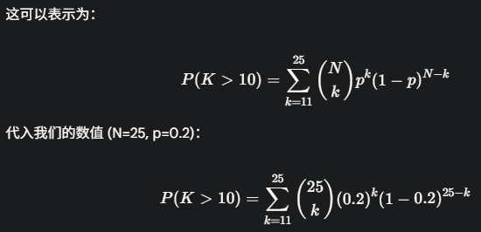
1 Mbps = 1 000 kbps
- b = bit（比特）
- B = Byte（字节）
1 Byte = 8 bits
因此 1 MB/s（大写 B，兆字节每秒）= 8 Mb/s（兆比特每秒）
运营商说的“100 Mbps 宽带” → 理论峰值下载速度
100 Mb/s ÷ 8 = 12.5 MB/s
考虑协议开销，真实能跑 11 MB/s 左右就算正常
记住“÷8”就能在 Mbps 与 MB/s 之间快速切换

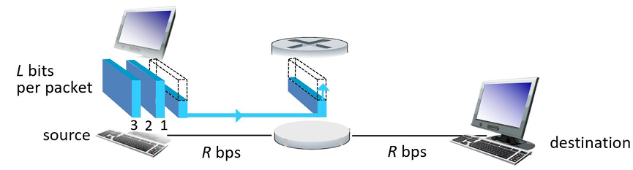
- First packet arrives at destination after 2 × (L/R).
- Second packet after 3 × (L/R).
- Third packet after 4 × (L/R).
Therefore, the overall latency to receive all the three packets is 4 × (L/R).
传输时延问题：store-forward-delay，包含2个过程：接收和转发
单向传输一个包的时延 = L / R 秒，包的大小 (L) 和链路带宽 (R) 决定。由于包含接收和转发，所以第一个包是2L / R. 由于同步进行的，后续的包的接受转发都只要L / R，总共 4L / R。

从 问题 3：时延的完整模型是什么？应用层架构视角
端到端时延 (End-to-End Delay)：多了几种类型而已，加起来就行
The four types of delay are: 1. Nodal processing delay “信息打包跑路” 2. Queueing delay“安检排队时间” 3. Transmission delay“传输时间” 4. Propagation delay“传播时间”
(ii) Please explain the difference between the queueing delay and transmission delay.
Queueing delay is the time a packet waits in a buffer before being transmitted. Transmission delay is the time required to push all bits of a packet onto the link. Transmission (传输) 是“把数据推进管子里的时间”。
Propagation (传播) 是“数据在管子里流动的时间”。
(iii) Please explain the reason for the packet loss.
Physical condition: routers have limited buffer space storage, when the buffer is fully used, the newly coming packet is lost.
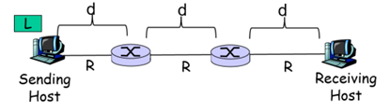
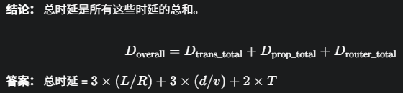

4. 从 问题 4：如何基于这个网络构建大规模应用？
问题是：我们现在要分发一个大文件 $F$ 给海量的用户 $N$ ¹⁴，怎样才能最快？
客户端/服务器 (Client/Server, C/S) 和 对等 (Peer-to-Peer, P2P) ：
C/S模式下：
分发时间 不 是两者（服务器上传和客户端下载）之和，必须 是取两者中的最大值 (max)。你不能把它们加起来，因为服务器上传和客户端下载，这两个过程是并行发生的，而不是串行的。
服务器并不是先把文件“上传”到某个地方，然后 客户端再从那里“下载”。 真实情况是：服务器在“上传”数据的 同时，客户端就在“下载”这些数据。
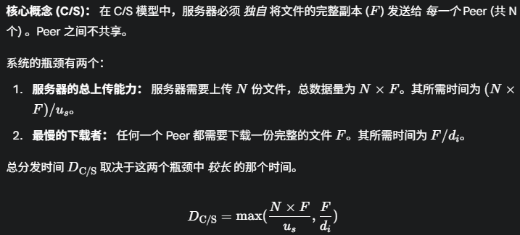

对等 (Peer-to-Peer, P2P)：总量不变，但是所有Peer都可以用来上传，分摊NF
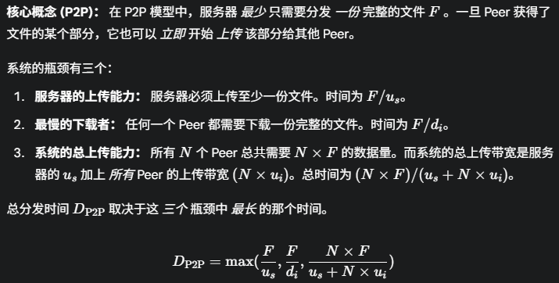
对比结论：
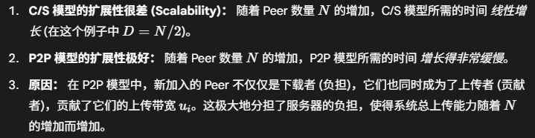
假设N无穷的时候，变成求极限问题：
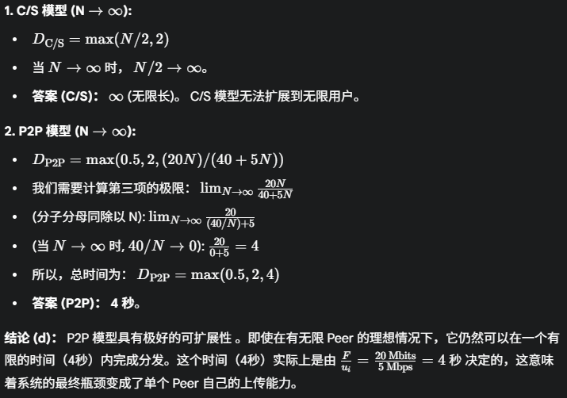
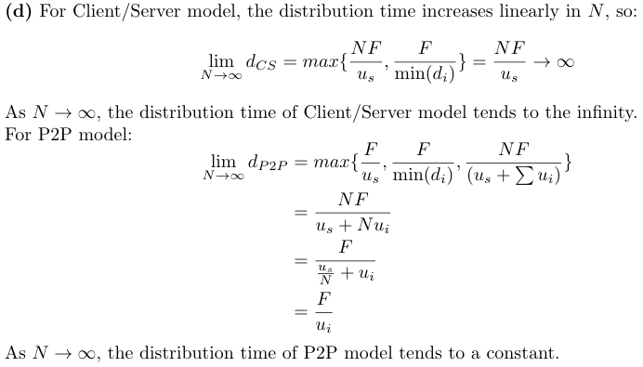
Question 3 (5 points): Please specify the difference between the Client/Server (CS) service model and Peer-to-Peer (P2P) service model.
Client/Server (CS):
server:
- always-on host
- permanent address
clients:
- communicate with server
- do not communicate directly with each other
Peer-to-Peer (P2P):
- no always-on server
- end systems can communicate with each other as the “peers”
- Highly scalable but difficult to manage

Regarding the layered protocol in Internet：
(i) please specify the names of the five layers in the TCP/IP reference model. (5 points)
(ii) Please specify the names of the seven layers in the ISO/OSI reference model. (5 points)
Answer: ATNLP
TCP/IP 五层模型 | ISO/OSI 七层模型
5 Application | 7 Application
4 Transport | 6 Presentation
3 Network | 5 Session
2 Link | 4 Transport
1 Physical | 3 Network
 | 2 Data Link
 | 1 Physical

数据链路层（MAC 地址、ARP）和网络层（IP 地址、路由算法）

MAC 地址是一个 48 位的地址，通常用 12 个十六进制 (Hexadecimal) 数字表示。每个十六进制数字用4 个比特 (bit) 代表。 9A = 1001 1010

MAC 地址 "FF-FF-FF-FF-FF-FF" 有什么特殊含义？ IP 全1是广播
这是广播 MAC 地址 (Broadcast MAC Address) 。在数据链路层，一个发往此地址的数据帧 (frame) 将被该局域网 (LAN) 上的 所有 设备接收和处理。

MAC 地址和 IP 地址有什么区别？
答案： 它们是两种不同层级、不同用途的地址 ：
- 层级不同： MAC 地址是数据链路层（Layer 2）地址，IP 地址是网络层（Layer 3）地址。
- 寻址范围不同：
  - MAC 地址 用于在一个 本地局域网 (LAN) 内部的“逐跳”(hop-by-hop) 寻址。它标识的是“下一跳”的物理设备。
  - IP 地址 用于在 全球互联网（跨越多个网络）上的“端到端”(end-to-end) 寻址。它标识的是通信的“最终源”和“最终目的”。
- 格式和分配不同：
  - MAC 地址 是 48 位的，通常由硬件制造商“烧录”在网卡 (NIC) 上，理论上是全局唯一且扁平的。
  - IP 地址 (IPv4) 是 32 位的，是逻辑地址，具有层次结构（网络号 + 主机号），通常由网络管理员或 DHCP 动态分配。
The differences between the MAC address and IP address are:
- Layer: A MAC address is a Layer 2 (Data Link Layer) address, while an IP address is a Layer 3 (Network Layer) address.
- Scope: A MAC address is used for local, hop-by-hop addressing within a single network. An IP address is used for global, end-to-end addressing across the entire internet.
- Mutability: MAC addresses are typically permanent and unique. IP addresses are logical and can be changed, often being assigned dynamically.
- Format: MAC address is 48-bit. IPv4 address is 32-bit。

特性 (Feature) | MAC 地址 (MAC Address) | IP 地址 (IP Address)
所属层面 (Layer) | L2 (数据链路层, Data Link Layer) | L3 (网络层, Network Layer)
作用范围 (Scope) | 本地的 (Local)，跳到跳 (Hop-to-Hop)  只在同一个局域网 (LAN) 内部有效。 | 全局的 (Global)，端到端 (End-to-End)  负责在整个互联网上标识源和目的。
地址结构 | 扁平的 (Flat)  48-bit，没有逻辑结构。 | 分层的 (Hierarchical)  分为网络部分 (Subnet part) 和主机部分 (Host part)。
大小与格式 | 48 bits (6 字节)  e.g., 0A-2F-BB-76-09-AD | 32 bits (IPv4) e.g., 223.1.1.1  128 bits (IPv6)
分配方式 | 物理分配 (Physical)  由硬件制造商烧录在网卡 (NIC) ROM 中。 | 逻辑分配 (Logical)  由网络服务商(ISP)或本地网络 (DHCP 服务器) 分配。
是否改变? | 永久不变 (Permanent)  （除非你伪造它） | 临时的 (Temporary)  当你更换网络时，IP 地址就会改变。
使用设备 | 交换机 (Switch) (L2 设备) | 路由器 (Router) (L3 设备)

IP 地址是“端到端”的，传输过程不会改变。在整个传输过程中，数据报 (datagram) 里的：
- 源 IP 地址 始终是主机 A 的 IP (111.111.111.111) 。
- 目的 IP 地址 始终是主机 B 的 IP (222.222.222.222) 。

MAC 地址是“逐跳”的，只在本地 LAN 内有效，一跳就改变。当数据包从一个网络（A 所在的网络）跨越到另一个网络（B 所在的网络）时，MAC 地址必须改变。

"ARP" 指的是什么？
答案： ARP 指的是 地址解析协议 (Address Resolution Protocol) 。

假设主机 A 要发送数据报给同一局域网的主机 B。A 知道 B 的 IP，但不知道 B 的 MAC。请说明 A 运行 ARP 获取 B 的 MAC 地址的步骤。
答案： ARP 的工作流程如下：局域网内广播，然后收到私信
- A 构造 ARP 请求 (Request)： 主机 A 创建一个 ARP 请求包。这个包里包含了 A 自己的 IP 和 MAC 地址，以及它想查询的主机 B 的 IP 地址 。请求的“问题”是：“IP 地址为 [B的IP] 的主机，你的 MAC 地址是什么？”
- A 广播 ARP 请求： 主机 A 将这个 ARP 请求包放入一个数据链路层帧中。这个帧的目的 MAC 地址是广播地址 (FF-FF-FF-FF-FF-FF) 。
- LAN 内所有主机接收： 局域网内的所有设备（包括 B）都会收到这个广播帧。
- B 识别并响应： 其他主机看到 ARP 请求中的 IP 不是自己的，就丢弃它。主机 B 识别到 ARP 请求中的 IP 地址是自己的 ，于是准备一个 ARP 响应 (Reply) 包。
- B 构造 ARP 响应： B 的响应包中包含 B 自己的 IP 地址和 MAC 地址。
- B 单播响应给 A： 主机 B 将这个 ARP 响应包放入一个帧中，这次的目的 MAC 地址是 A 的 MAC 地址（A 在第 1 步的请求中已经告诉 B 了）。这个响应是单播 (unicast) 的。
- A 收到响应并缓存： A 收到 B 的响应，从中提取出 B 的 MAC 地址 ，并将这个 (B的IP, B的MAC) 映射关系存储在自己的 ARP 缓存 (Cache) 中，以便将来直接使用。
- A broadcasts ARP query packet, containing B’s IP address: destination MAC address=FF-FF FF-FF-FF-FF. All nodes on LAN receive ARP query.
- B receives ARP packet, replies to A with B’s MAC address: frame sent to A’s MAC address (unicast).
- A saves IP-to-MAC address pair in its ARP table until information becomes old (times out).

Dijkstra algorithm 必备
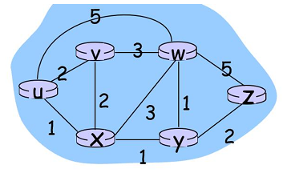
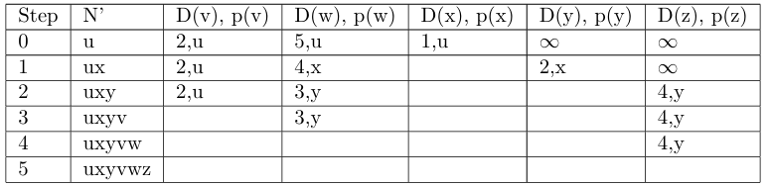
1、N`表示已经确认的最短路，D(x)表示最短路任意出发到达当前x节点的最短距离，p(x)表示最短路径的末尾节点（到达前节点）。
2、成本一样时，随便选

距离向量 (Distance-Vector) 算法
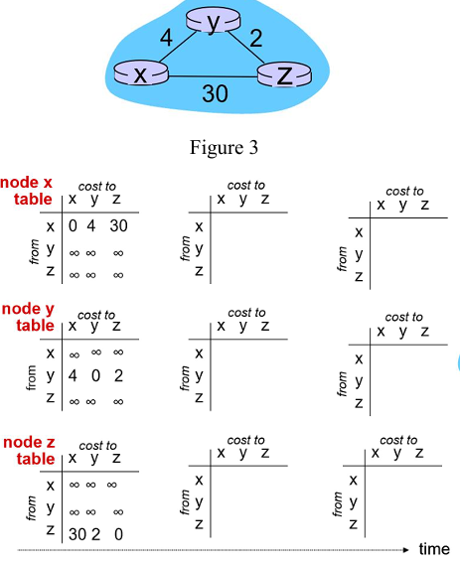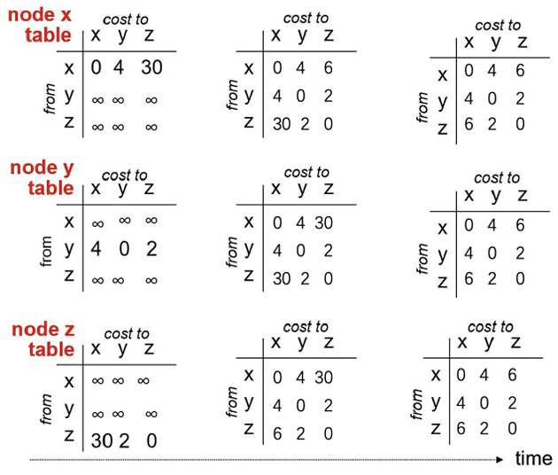
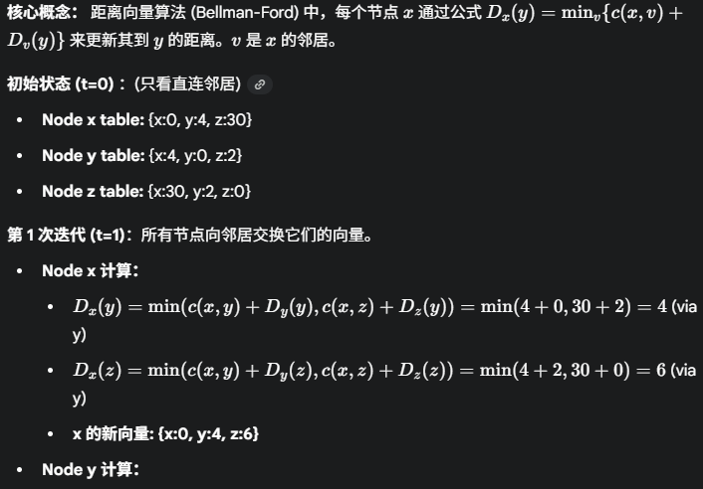
思路：中间组只更新自己当前节点，其他2个节点只接受信息，最后一组全部更新好，直接填最近距离。
算法局限性：如果 x 和 y 之间的链路成本增加到 60 ，算法会快速收敛吗？
No, because "Count to Infinity" problem. Bad news travels slow.
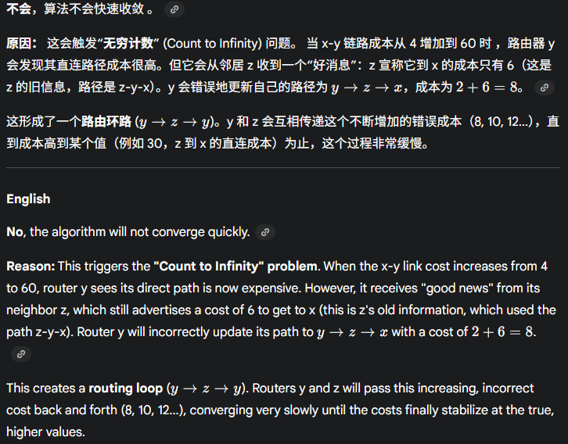

自治系统：
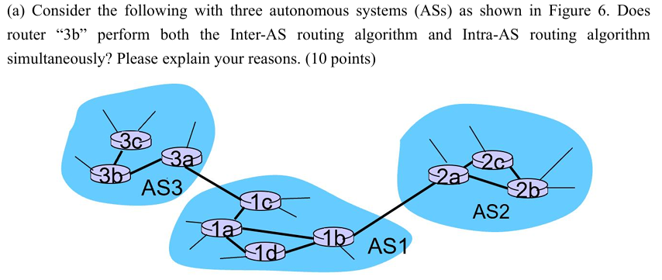
No，router 3b only performs Intra-AS routing algorithm. Because router 3b is not the gateway router. Gateway routers (3a, 1c, 1b, 2a) need to perform both the Inter-AS routing algorithm and Intra-AS routing algorithm simultaneously.

请分别举一个 Intra-AS 路由算法和 Inter-AS 路由算法的例子。
答案：
- Intra-AS 路由算法（在一个 AS 内部使用）：
  - RIP (Routing Information Protocol)：基于“距离向量”算法。
  - OSPF (Open Shortest Path First)：基于“链路状态”算法。
- Inter-AS 路由算法（在不同的 AS 之间使用）：
  - BGP (Border Gateway Protocol)：边界网关协议。它是当今互联网上使用的标准 Inter-AS 协议，基于“路径向量”算法。

Question 6 (10 points): Please specify three types of network attacks.
Denial of Service (DoS), Packet “sniffing”, IP spoofing.

What is the key functionality of the data-link layer service? (4 points)
Data-link layer has responsibility of transferring datagram from one node to physically adjacent node over a link.

(a) Please specify three examples of MAC which are based on the rationale of “random access”.
- ALOHA 36%
- slotted ALOHA 18%
- CSMA, CSMA/CD, CSMA/CA collision
(b) Can CSMA completely avoid collisions? Please explain your solution. (5 points)
No, collisions can still occur since that propagation delay means two nodes may not hear each other’s transmission.
(c) What are the differences between CSMA/CD and CSMA/CA? (10 points)
CSMA/CD: Used in wired Ethernet. Detects collisions during transmission and aborts immediately.
CSMA/CA: Used in Wi-Fi (802.11). Cannot detect collisions; instead, avoids them using random backoff and timers.

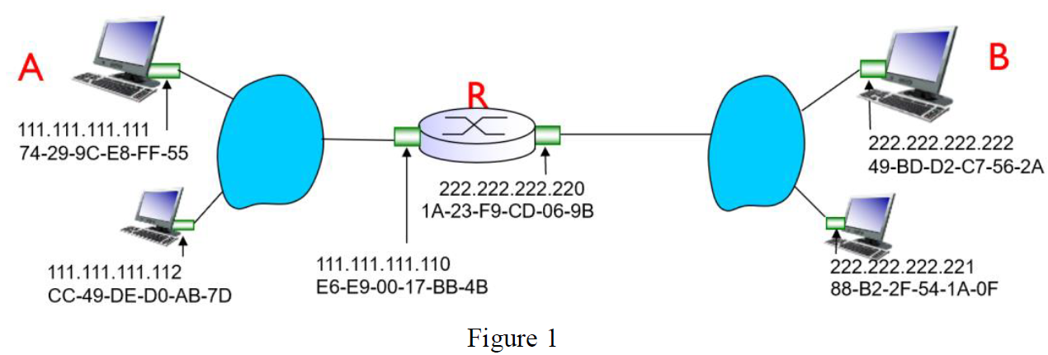
(a) As shown in Figure 1, suppose that host A sends a datagram to host B. Will the source/destin
ation IP addresses be changed when the datagram traverses through the router R?
No, source and destination IP addresses remain unchanged.
(b) As shown in Figure 1, suppose that host A sends a datagram to host B. Will the source/destination MAC addresses be changed when the frame traverses through the router R?
Yes, source and destination MAC addresses change at each hop.

(a) What are the differences between the function of the network layer and the function of the data link layer? (10 points)
1. Network Layer (Layer 3)：For end-to-end (Source-to-Destination) communication across multiple interconnected networks. It handles the global delivery of data from the source host to the destination host.
- Primary Function: Routing (determining the best path) and Forwarding (moving packets from input to output port) of datagrams.
- Addressing: Uses Logical Addresses (IP Addresses) for global identification and routing.
- Data Unit: Packet or Datagram.
2. Data Link Layer (Layer 2)：For Hop-to-Hop (Node-to-Node) local delivery of data across a single communication link. It manages the transfer of data between physically adjacent network elements (nodes).
- Primary Function: Data transfer between neighboring nodes, Media Access Control (MAC).
- Addressing: Uses Physical Addresses (MAC Addresses) for local device identification and access control.
- Data Unit: Frame.

(b) What the difference between the MAC address and IP address? (10 points)
MAC address: Physical identifier, fixed per device, used at link layer.
IP address: Logical identifier, can change, used at network layer.

Regarding the IP fragmentation, suppose that there is a datagram of 5000 bytes, and the MTU of the link is 1000 bytes. How many datagrams will be generated after the IP fragmentation, and why? (5000-20) / 980 向上取整
Total 6 datagrams.
Original datagram: length=5000, fragflag=0, there are 4980 bytes in data field.
1st datagram: length=1000, fragflag=1, there are 980 bytes in data field.
2nd datagram: length=1000, fragflag=1, there are 980 bytes in data field.
3rd datagram: length=1000, fragflag=1, there are 980 bytes in data field.
4th datagram: length=1000, fragflag=1, there are 980 bytes in data field.
5th datagram: length=1000, fragflag=1, there are 980 bytes in data field.
6th datagram: length=100, fragflag=0, there are 80 bytes in data field.
Because of those 5 fragments of 1000 bytes each (980 bytes data + 20 bytes header), all with “more fragments” flag = 1. 1 final fragment of 100 bytes (80 bytes data + 20 bytes header), “more fragments” flag = 0.

Question 2: (10 points)
- What does "CIDR" refer to? (5 points)
Classless Inter-Domain Routing. Subnet portion of address of arbitrary length. Address format a.b.c.d/x, where x is subnet prefix length.
(b) What does "DHCP" refer to? (5 points)
Dynamic Host Configuration Protocol. Automatically assigns IP addresses to hosts.

Question 3: (10 points) Regarding the shortage of the IPv4 addresses, please specify two ways to address this issue of the shortage of the IPv4 addresses.
Solution: (a) Use NAT (Network Address Translation). (b) Upgrade to IPv6.

Question 4: (20 points)
(a) To identify a TCP socket, what are the 4-tuple information required? (5 points)
Source IP address, destination IP address, source port number, and destination port number.
(b) To identify a UDP socket, what are the 2-tuple information required? (5 points)
Destination IP address and destination port number.
(c) What are the differences between TCP and UDP? (10 points)
TCP | UDP
- Connection management  - Connection-oriented  - Send and receive buffers exist  - Full duplex data  - Reliable data transfer  - Flow controlled  - Congestion controlled | - No connection establishment (which can add delay)  - Simple: no connection state at sender, receiver  - Small header size  - No congestion control: UDP can blast away as fast as desired

Question 5: (5 points) What are the three mechanisms to realize the reliable data transfer protocols?
FST：Feedback (control messages (ACK, NAK) from receiver to sender), sequence number, and timer.

Question 6: (15 points)
Consider the situation of RDT: reliable data transfer. Each packet size is 5000bits. The link bandwidth is 5Mbits/ sec. The single-trip signal propagation delay is 0.005sec.
(a) What is the utilization ratio of this link if the stop-and-wait based reliable data transfer protocol is adopt? (5 points)
Round Trip Time (𝑅𝑇𝑇)=2∗0.005=0.01 𝑠𝑒𝑐
L/R=5000/5000000=0.001 sec
$$U=\frac{L/R}{RTT+L/R}=\frac{0.001}{0.01+0.001}=0.0909$$
(b) How to improve the utilization ratio of this link? To make a full utilization of the link, what is the maximum number of packets which can be sent without requiring acknowledgement? (5 points)
Use pipelined protocols (Go-Back-N or Selective Repeat). Maximum packets in flight = RTT/(L/R) + 1 = 11.
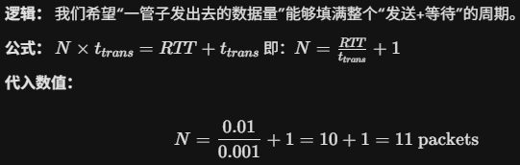
(c) What are the differences between the GBN protocol and selective repeater protocol?
Go-back-N | Selective Repeat
- Sender can have up to N unacked packets in pipeline  - Receiver only sends cumulative ack: doesn’t ack packet if there’s a gap  - Sender has timer for oldest unacked packet: when timer expires, retransmit all unacked packets | - Sender can have up to N unacked packets in pipeline  - Receiver sends individual ack for each packet  - Sender maintains timer for each unacked packet: when timer expires, retransmit only that unacked packet

Question 7: (20 points)
(a) What are the differences between TCP congestion control and TCP flow control? (5 points)
Flow control: Avoid the sender overflowing receiver’s buffer by transmitting too much, too fast.
Congestion control: Avoid too many sources sending too much data too fast for network to handle.
(b) What are the three mechanisms used for TCP congestion control? (10 points)
AIMD (Additive Increase, Multiplicative Decrease), slow start, and conservative after timeout events.
(c) Please explain why TCP needs to perform the fast-transmission mechanism after receiving three duplicated ACKs? (5 points)
After the sender receives 3 duplicate ACKs, it assumes that the packet is lost and retransmit that packet without waiting for a retransmission timer to expire.

Question 8: (10 points)
(a) What does DNS refer to? (5 points)
DNS: Domain Name System.
(b) What are the two query-schemes used by DNS? (5 points)
Two query schemes: Iterative query and Recursive query.
Iterative and recursive

拥堵控制：
事件 | 图中肉眼标志 | 要记录的 RTT 序号 | 备注
slow start | 当前 cwnd < 红色“+”(ssthresh 会变) | 所有满足该不等式的 t | 指数增
congestion avoidance | 当前 cwnd ≥ ssthresh | 所有满足该不等式的 t | 线性增
timeout 丢包 | 前一 RTT 后 cwnd 直接掉到 1 | 掉到 1 的那一 RTT | 同时 ssthresh 被设为丢包前 cwnd/2
3-重复 ACK 丢包 | 前一 RTT 后 cwnd 减半但未到 1 | 减半的那一 RTT | 同时 ssthresh 也被设为减半值
ssthresh 变化 | 红色“+”纵坐标跳变（总是向下） | 跳变后所在的 RTT。数值变成当前点的一半 | 只记变化后的那个 t；若在 t 与 t+1 之间变，写 t+1
fast recovery | 紧随“3-重复 ACK”后的 1~2 个 RTT，cwnd 线性 +1 | 从“减半”那一 RTT 开始，直到 cwnd 再次 ≥ 新 ssthresh 前为止 | 超时不会进入此阶段
- congestion avoidance 的最后一个 t 与 timeout 丢包事件是 同一 RTT；
- timeout 丢包时刻 t 与 slow start 的第一个 RTT (t+1) 在图上相邻，序号不重合，但因果连续。

重合的“事件对” | 是否落在同一 RTT 序号 | 说明
congestion avoidance 最后一格 vs 丢包检测事件 | ✅ 同一 RTT t | 该 RTT 送完数据后收到 timeout/3-ACK，丢包被检测到
丢包检测 vs ssthresh 跳变 | ✅ 同一 RTT t 末尾 | 算法立即把 ssthresh 设为原 cwnd/2，红色“+”同步下移
ssthresh 跳变 vs cwnd 骤降 | ✅ 同一 RTT t 末尾 | timeout→cwnd 直接 1；3-ACK→cwnd 减半，都画在 t→t+1 之间
timeout 丢包 vs slow start 开始 | ❌ 相邻 RTT | 丢包在 t，新 cwnd=1 画在 t+1，所以序号 不重合
3-duplicate-ACK 丢包 vs fast recovery 开始 | ❌ 相邻 RTT | 丢包在 t，减半后的 cwnd 画在 t+1，随后线性+1
fast recovery 结束 vs 回到 congestion avoidance | ❌ 相邻 RTT | 恢复阶段最后一个 RTT 满足 cwnd≥新 ssthresh，下一 RTT 就是纯 CA

额外考点：
如果说还有哪些同等重要的知识点，我首推传输层 (Transport Layer)，以及几个关键的“粘合剂”协议。这些是几乎所有网络课程的必考点。
我们来复习一下：
1. 核心中的核心：传输层 (TCP vs. UDP)
这是你到目前为止的作业中缺失的最大一块。传输层是连接“应用程序”（如浏览器）和“网络层”（IP 路由）的桥梁。
- TCP (Transmission Control Protocol - 传输控制协议)
  - 特点： 可靠的、面向连接的服务。
  - 打个比方： 像打电话。你必须先“拨号”（建立连接），双方确认后才能开始通话（传输数据），并且你能确保对方听到了你说的每一句话（可靠性），最后“挂断”（释放连接）。
  - 适用： 网页浏览 (HTTP)、文件传输 (FTP)、电子邮件 (SMTP)。任何不允许数据出错或丢失的场景。
- UDP (User Datagram Protocol - 用户数据报协议)
  - 特点： 不可靠的、无连接的服务。也称为“尽力而为”(best-effort)。
  - 打个比方： 像寄明信片。你直接把明信片（数据包）丢进邮筒，不保证它能送到，也不保证按顺序送到，更不保证不丢失。
  - 适用： 视频直播、在线游戏、语音通话 (VoIP)。这些场景对实时性要求高，宁可丢掉一帧画面，也不愿为了重传一个旧数据而卡顿。

2. TCP 的两大支柱（必考）
几乎所有关于 TCP 的问题都会围绕这两点：
- 可靠数据传输 (Reliable Data Transfer)
  - 问题： IP 网络是不可靠的，包可能会丢失、乱序。TCP 如何在不可靠的 IP 之上提供可靠的服务？
  - 答案： 使用序列号 (Sequence Numbers) 和 确认号 (Acknowledgement Numbers, ACK)。
  - 机制： 发送方给每个包编号 (Seq)，接收方收到后回复一个确认号 (ACK)，告诉发送方“我下一个期望收到的是几号包”。如果发送方在一定时间内没收到 ACK（超时），它就重传那个包。
- 拥塞控制 (Congestion Control)
  - 问题： 这就是 HW1 中 Q1(b) ³的宏观解决方案。如果太多主机（像那 25 个 ⁴）同时高速发送数据，网络链路（那个 1 Mbps ⁵）就会崩溃。TCP 如何避免塞爆网络？
  - 答案： TCP 会动态调整自己的发送速率。
  - 机制：
    - 慢启动 (Slow Start)： 刚开始时，发送速率呈指数增长。
    - 拥塞避免 (AIMD)： 达到一个阈值后，改为“加法增大”（每轮增加一个包）来缓慢探测网络容量。
    - 拥塞检测： 一旦发生丢包（即超时或收到 3 个重复 ACK），TCP 就认为网络拥塞了，立刻“乘法减小”，将发送速率减半。

3. 关键的“粘合剂”协议
它们就像 HW2 中的 ARP一样，负责在不同层级或不同网络间进行“翻译”和“连接”。
- DNS (Domain Name System - 域名系统)
  - 作用： 它是一个应用层协议，但服务于整个网络。
  - 功能： 帮你把人类可读的域名（如 www.google.com）“翻译”成机器可读的 IP 地址（如 142.250.191.78）。这是你输入网址后，浏览器做的第一件事。
- NAT (Network Address Translation - 网络地址转换)
  - 作用： 这是一个网络层技术。
  - 功能： 允许你家里（或公司）的多台设备（使用如 192.168.1.x 这样的私有 IP）共享一个公网 IP 地址来访问互联网。
  - 联系： 这与 HW2 中 Q1(e) ⁷ 路由器重写 MAC 地址的概念很像，但 NAT 是在 IP 层重写 IP 地址和端口号。
- DHCP (Dynamic Host Configuration Protocol - 动态主机配置协议)
  - 作用： 你电脑一连上 Wi-Fi，是如何自动获得 IP 地址、子网掩码、网关（路由 R ⁸）地址和 DNS 服务器地址的？
  - 功能： DHCP 负责自动分配这些网络配置信息。

4. 网络层与数据链路层的深化
- 子网划分 (Subnetting) 和 CIDR
  - HW2 里的 IP (如 111.111.111.111 ⁹) 是简化的。现实中，IP 地址被“子网掩码”分为“网络部分”和“主机部分”。这是 IP 地址如何被高效分配和聚合（路由）的核心。
- 交换机 (Switch) vs. 路由器 (Router)
  - 这是 HW2 知识的直接延伸。
  - 交换机 (Switch)： 工作在数据链路层 (Layer 2)。它在 一个 局域网 (LAN) 内部根据 MAC 地址 转发数据帧。它通过“自学习”来建立 MAC 地址表。
  - 路由器 (Router)： 工作在网络层 (Layer 3)。它连接 不同 的网络（如 HW2 图 1 ¹⁰中的两个局域网），根据 IP 地址 转发数据包。它通过运行路由算法（如 OSPF¹¹, BGP）来建立路由表。

这些主题——尤其是 TCP 的可靠性与拥塞控制、DNS 和 NAT——几乎是每门网络课程的期中和期末必考内容。
你想先详细了解哪一个？比如，我们可以深入讲讲 TCP 是如何建立连接（三次握手）的。

📚 课程总复习 (Course Review)
为什么分层 (Why Layering)?
网络是一个极其复杂的系统。我们使用分层模型来管理复杂性 (deal with complex systems)。每一层为其上层 (upper layer) 提供服务，并使用其下层 (lower layer) 提供的服务。这实现了模块化 (modularization)，使得任何一层的实现都可以被改变，而不会影响到系统的其他部分。

Layer 5: Application Layer (应用层)
这是你作为程序员和用户直接交互的一层。
- 功能: 为网络应用提供服务。
- 数据单元: Message (报文)。
- 协议举例: HTTP (Web), SMTP (Email), FTP, DNS。
- 考纲知识点: Client-Server Model vs. Peer-to-Peer Model
  - 这是两种最主要的应用架构 (application architectures)。
  - Client-Server (C/S):
    - 有一个始终在线 (always-on) 的服务器 (Server)，它有永久 IP 地址 (permanent IP address)。
    - 客户端 (Clients) 主动向服务器发起请求，客户端之间不直接通信。
    - 扩展性 (Scalability) 较差，服务器易成为瓶颈。
  - Peer-to-Peer (P2P):
    - 没有 always-on 的中心服务器。
    - 任意终端系统（称为 Peers）直接相互通信 (directly communicate)。
    - 高度可扩展 (Highly scalable)，因为每个 Peer 既是客户端也是服务器。
    - Lecture1.pdf 和 Lecture12.pdf 中的文件分发时间对比图 完美展示了 P2P 在可扩展性上的巨大优势。

Layer 4: Transport Layer (传输层)
- 功能: 提供进程到进程 (process-to-process) 的逻辑通信 (logical communication)。
- 寻址 (Addressing): 使用 端口号 (Port Numbers) 来实现多路复用 (Multiplexing) 和解复用 (Demultiplexing)，即把数据交给正确的应用程序。
- 数据单元: Segment (段)。
- 考纲知识点: TCP/UDP
  - UDP (User Datagram Protocol):
    - “无修饰 (no-frills)” 的协议。
    - 无连接 (Connectionless)。
    - 不可靠 (Unreliable)、尽力而为 (best-effort) 的服务。它会丢包、会乱序。
    - 为什么用它? 速度快、开销小、没有连接建立延迟。适用于流媒体、DNS、VoIP。
  - TCP (Transmission Control Protocol):
    - 面向连接 (Connection-oriented)：在传输数据前，必须通过三次握手 (3-way handshake) 建立连接。
    - 可靠数据传输 (Reliable Data Transfer)：提供可靠的、按序的字节流 (reliable, in-order byte stream)。
    - 流量控制 (Flow Control)：防止发送方淹没 (overwhelm) 接收方的缓冲区 (receiver's buffer)。
    - 拥塞控制 (Congestion Control)：防止发送方淹没 (overwhelm) 整个网络 (the network)。
- 考纲知识点: Principle of Reliable Data Transfer (RDT)
  - 这是 TCP 实现“可靠”的核心理论。
  - 演进过程：
    - RDT 1.0 (可靠信道): 完美世界，只需发送和接收。
    - RDT 2.0 (有比特差错): 引入差错检测 (Checksum)、ACK (确认) 和 NAK (否认)。
    - RDT 2.1/2.2 (ACK/NAK也出错): 引入序列号 (Sequence Numbers) 来处理重复包 (duplicate packets)。
    - RDT 3.0 (信道会丢包): 引入倒计时器 (Countdown Timer) 来实现超时重传 (timeout retransmission)。这就是**“停等 (Stop-and-Wait)”** 协议。
  - Pipelining (流水线): Stop-and-Wait 效率极低。流水线允许发送多个未确认的包，以提高利用率。
    - Go-Back-N (GBN): 使用累积确认 (cumulative ACKs)，接收方丢弃所有乱序的包。
    - Selective Repeat (SR): 使用独立确认 (individual ACKs)，接收方缓冲 (buffers) 乱序的包。
- 考纲知识点: TCP Congestion Control
  - 目标： 防止网络崩溃，实现公平性 (fairness)。
  - 感知拥塞： 通过“丢包事件 (loss event)”来推断，即 Timeout 或 3 次重复的 ACK (3 duplicate ACKs)。
  - 核心算法 (AIMD)：
    - Additive Increase (加法增大): 每过一个 RTT，CongWin (拥塞窗口) 增加 1 MSS。这是在“探测”可用带宽。
    - Multiplicative Decrease (乘法减小): 发生丢包时，CongWin 减半。
  - 启动算法 (Slow Start):
    - 连接刚开始时，CongWin 设为 1 MSS，然后指数增长（每个 RTT 翻倍），直到达到 Threshold (阈值)。
    - Timeout (严重拥塞) 会导致 CongWin 重置为 1，重新慢启动。
    - 3 个重复 ACK (轻微拥塞) 只需将 CongWin 减半并进入 AIMD（这被称为 Fast Recovery）。

Layer 3: Network Layer (网络层)
- 功能: 提供主机到主机 (host-to-host) 的数据传输，负责在整个互联网中路由 (routing) 和转发 (forwarding) 数据报。
- 寻址: IP Address (IP 地址)。
- 数据单元: Datagram (数据报)。
- 考纲知识点: Circuit Switching vs. Packet Switching
  - 这是网络核心 (Network Core) 的两种基本工作模式。
  - Circuit Switching (电路交换): 预留 (reserved) 端到端资源。如传统电话。优点： 性能有保证 (guaranteed performance)。缺点： 资源利用率低 (inefficient)，因为预留的资源可能被空闲浪费。
  - Packet Switching (分组交换): 按需共享 (on-demand, shared) 资源。这是互联网的方式。优点： 资源利用率高，通过统计多路复用 (Statistical Multiplexing) 支持突发流量 (bursty traffic)。缺点： 性能无保证 (best-effort)，可能发生拥塞 (congestion) 和丢包 (packet loss)。
- 考纲知识点: IP Protocol
  - IP Datagram Format (IPv4): 包含版本、首部长度、TTL (Time-to-Live, 防止无限循环)、上层协议号 (Protocol, 6=TCP, 17=UDP)、源/目的 IP 地址等。
  - IP Addressing: 使用 32 位的 IPv4 地址，通过 CIDR (a.b.c.d/x) 表示法划分子网 (Subnets)。
  - Fragmentation (分片): 当 IP Datagram 大于链路的 MTU (Maximum Transfer Unit) 时，路由器会将其切割成多个分片。分片只在最终目的主机上重组 (reassembled)。
  - NAT (Network Address Translation): 允许多个内部私有 IP 地址共享一个公共 IP 地址，用于缓解 IPv4 地址耗尽问题。
  - IPv6: 使用 128 位地址解决地址耗尽问题，并简化了头部（如，不允许中间路由器分片）。
- 考纲知识点: Routing Algorithms
  - 路由算法的目的是构建转发表 (forwarding table)。
  - Link-State (LS) (如 OSPF):
    - 全局信息 (Global info): 每个节点都知道整个网络的拓扑。
    - 算法： 节点在本地独立运行 Dijkstra 算法来计算最短路径。
  - Distance-Vector (DV) (如 RIP):
    - 分布式 (Decentralized)： 节点只与邻居通信，交换彼此的距离向量 (Distance Vectors)。
    - 算法： 节点使用贝尔曼-福特方程 (Bellman-Ford equation) 迭代更新自己的 DV。
    - 问题： 存在计数到无穷 (Count-to-Infinity) 问题。

Layer 2: Link Layer (数据链路层)
- 功能: 负责在相邻 (adjacent) 节点之间（即一“跳” hop）传输数据。
- 寻址: MAC Address (物理地址)。
- 数据单元: Frame (帧)。
- 考纲知识点: Medium Access Control (MAC)
  - 问题： 解决在广播链路 (broadcast link)（如 Wi-Fi 或老式以太网）上发生的碰撞 (collision) 问题。
  - ALOHA (随机访问):
    - Pure ALOHA: 立即发送，效率低 (Max 18%)。
    - Slotted ALOHA: 仅在时隙初发送，效率加倍 (Max 37%)。
  - CSMA/CD (碰撞检测):
    - 用于: 有线以太网 (Wired Ethernet)。
    - 机制: "Listen before talk" (CSMA) + "Listen while talk" (CD)。
    - 一旦检测到碰撞，立即停止 (abort) 发送。
  - CSMA/CA (碰撞避免):
    - 用于: 无线局域网 Wi-Fi (802.11)。
    - 机制: CD 在无线环境中不可行。它通过随机退避 (random backoff) 和 IFS 计时器来避免 (avoid) 碰撞。发送方在发送前等待一个随机时间。
- 考纲知识点: Error Detection & CRC
  - 链路层负责检测在“一跳”中发生的比特差错。
  - 机制： 发送方添加 EDC (差错检测码)，接收方进行校验。
  - Parity (奇偶校验): 简单，但二维校验可以纠正 1 比特错误。
  - CRC (循环冗余校验): 工业界标准。基于多项式除法（模2）。发送方附加余数 (R)。接收方检查余数是否为零。

Layer 1: Physical Layer (物理层)
- 功能: 负责在物理介质（铜缆、光纤、无线电）上传输原始的比特流 (bits).

PPT例题
我已经帮你把你发给我的所有PPT都过了一遍，把所有计算题 (Calculation)、分析题 (Analysis/Tracing) 和关键问答 (Key Questions) 都提取出来了。

🏮 来自 Lecture 1 & 2: 核心性能分析 (Core Performance)
1. (Calculation) C/S vs. P2P 文件分发时间
这是一个非常经典的计算题，几乎必考。
- 题目 (Problem): 一个服务器 (Server) 要分发一个大小为 $F$ 的文件给 $N$ 个 peers。
  - 服务器上传带宽 (Server upload bandwidth) = $u_s$
  - Peer $i$ 的下载带宽 (Peer i download bandwidth) = $d_i$
  - Peer $i$ 的上传带宽 (Peer i upload bandwidth) = $u_i$
  - (假设网络核心带宽充足)
计算在 Client-Server (C/S) 模式和 Peer-to-Peer (P2P) 模式下，分发完毕的最小时间 (Minimum Distribution Time) 各是多少？
- 答案 (Solution):
  - C/S Time: $D_{CS} = \max \{ \frac{NF}{u_s}, \frac{F}{\min(d_i)} \}$
    - (解释：时间取决于两件事中较慢的：1. 服务器把 $N$ 份文件全部传完的时间；2. 下载最慢的那个客户端接收完一份文件的时间。)
  - P2P Time3:
$D_{P2P} = \max \{ \frac{F}{u_s}, \frac{F}{\min(d_i)}, \frac{NF}{u_s + \sum u_i} \}$
    - (解释：时间取决于三件事中最慢的：1. 服务器传完 一份 文件的时间；2. 下载最慢的客户端收完的时间；3. 整个系统（包括所有peers）总上传能力传完 $N$ 份文件的时间。)
  - 结论 (Key Takeaway): C/S 的时间随 $N$ 线性增长，而 P2P 的时间增长缓慢得多，扩展性 (scalability) 极强。
2. (Calculation) Packet Switching vs. Circuit Switching 延迟
- 题目 (Problem): 发送一个大小为 $L$ bits 的文件。从源到目的经过 1 个路由器（共 2 段链路）。
  - 每段链路的带宽 (Link bandwidth) = $R$ bps
  - 每段链路的传播延迟 (Propagation delay) = $d/v$
  - (忽略处理延迟等)
计算 Circuit Switching 和 Packet Switching (Store-and-Forward) 的总延迟各是多少？
- 答案 (Solution):
  - Circuit Switching: $\text{Total Delay} = (\text{Setup Time}) + \frac{d}{v} + \frac{d}{v} + \frac{L}{R}$
(假设 Setup Time 为 $t_s$) $\text{Total Delay} = t_s + 2 \cdot (\frac{d}{v}) + \frac{L}{R}$
    - (解释：一旦电路建立，数据就以 $R$ 的速率从头传到尾，只需要 1 个传输延迟 $\frac{L}{R}$。)
  - Packet Switching: $\text{Total Delay} = (\frac{d}{v} + \frac{L}{R}) + (\frac{d}{v} + \frac{L}{R}) = 2 \cdot (\frac{d}{v} + \frac{L}{R})$
    - (解释：因为是“存储转发”，中间路由器必须完整接收第一个包（耗时 $\frac{L}{R}$），然后再转发出去（再耗时 $\frac{L}{R}$）。所以总共有 2 个传输延迟。)
3. (Calculation) 4 种网络延迟 (Types of Delay)
- 题目 (Problem): 一个数据包在路由器中经历的总延迟 ($d_{\text{nodal}}$) 由哪几部分组成？
- 答案 (Solution): $d_{\text{nodal}} = d_{\text{proc}} + d_{\text{queue}} + d_{\text{trans}} + d_{\text{prop}}$
  - Processing Delay ($d_{\text{proc}}$): 处理延迟 (检查头部、查表)。
  - Queueing Delay ($d_{\text{queue}}$): 排队延迟 (等待被发送，由拥塞 (congestion) 决定)。
  - Transmission Delay ($d_{\text{trans}}$): 传输延迟 (把包推上链路的时间) = $\frac{L}{R}$。
  - Propagation Delay ($d_{\text{prop}}$): 传播延迟 (信号在物理介质上传播的时间) = $\frac{d}{s}$。
4. (Calculation) 统计复用 (Statistical Multiplexing)
- 题目 (Problem): 一个 1 Mb/s 的链路。每个用户在 "active" 时需要 100 kb/s，但 "active" 的时间只有 10%。
  - 如果用 Circuit Switching，能支持多少用户？
  - 如果用 Packet Switching，假设支持 35 个用户，超过 10 个用户同时 "active" 的概率是多少？
- 答案 (Solution):
  - Circuit Switching: $1 \text{ Mbps} / 100 \text{ kbps} = 10$ 个用户。
  - Packet Switching: (这是一个二项分布问题)
$$P(\text{>10 active})=1-\sum_{k=0}^{10}{ }({35 \atop k})(0.1)^{k}(0.9)^{35-k}$$
$$P(\text{>10 active})=\sum_{k=10}^{35}{ }({35 \atop k})(0.1)^{k}(0.9)^{35-k}$$
- 结论： 分组交换利用了用户的突发性，可以支持远超 10 个的用户。

🔗 来自 Lecture 3, 4, 6: 链路层 (Link Layer)
7. (Calculation) ALOHA 效率
- 题目 (Problem):
  - Pure ALOHA 的最大效率是多少？
  - Slotted ALOHA 的最大效率是多少？
  - Slotted ALOHA 中，有 $N$ 个节点，每个以 $p$ 概率发送，任意一个节点成功发送的概率是多少？
- 答案 (Solution):
  - Pure ALOHA: 1/(2e) ≈ 18%
  - Slotted ALOHA: 1/e ≈ 37%
  - $P_{\text{success}}=N⋅p⋅(1-p)^{N-1}$

🖥️ 来自 Lecture 7 & 8: 网络层 (Network Layer)
8. (Analysis) MAC 与 IP 地址
- 题目: 主机 A 发送一个 Datagram 给主机 B，中间经过一个路由器 R。
  - A 的 IP: IP_A, A 的 MAC: MAC_A
  - R 的接口1 IP: IP_R1, MAC: MAC_R1
  - R 的接口2 IP: IP_R2, MAC: MAC_R2
  - B 的 IP: IP_B, B 的 MAC: MAC_B
问：A 发送给 R 的帧 (Frame) 和 R 发送给 B 的帧，它们的源/目的 IP 和源/目的 MAC 分别是什么？
- 答案 (Solution):
  - Frame from A to R:
    - Source IP: IP_A
    - Dest IP: IP_B (IP 地址全程不变)
    - Source MAC: MAC_A
    - Dest MAC: MAC_R1 (MAC 地址只管下一跳)
  - Frame from R to B:
    - Source IP: IP_A
    - Dest IP: IP_B
    - Source MAC: MAC_R2
    - Dest MAC: MAC_B
9. (Analysis) 交换机自学习 (Switch Self-Learning)
- 题目 (Problem): 一个交换机 (Switch) 刚启动，转发表 (switch table) 为空。
  - 主机 A (在接口1) 发送一个帧给主机 A' (在接口4)。
  - 之后，A' 发送一个帧给 A。
交换机在这两步中分别会做什么？转发表如何变化？
- 答案 (Solution):
  - A -> A':
    - Learn (学习): 交换机收到来自接口 1 的帧，记录 (MAC_A, 1) 到转发表中。
    - Forward (转发): 交换机在表中查找 MAC_A'，找不到 (unknown)。因此，它广播 (floods) 这个帧到除接口 1 外的所有其他接口 (2, 3, 4, 5, 6)。
  - A' -> A:
    - Learn (学习): 交换机收到来自接口 4 的帧，记录 (MAC_A', 4) 到转发表中。
    - Forward (转发): 交换机在表中查找 MAC_A，找到了 (在接口 1)。因此，它选择性地 (selectively) 只将该帧转发到接口 1。
📈 来自 Lecture 7 & 12: 路由算法 (Routing Algorithms)
12. (Analysis) Dijkstra 算法 (Link-State)
- 题目 (Problem):
给定一张网络拓扑图（如 Lecture7, page 52），使用 Dijkstra 算法计算从源节点 u 到所有其他节点的最短路径。
13. (Analysis) Bellman-Ford 算法 (Distance-Vector)
- 题目 (Problem): 使用 Bellman-Ford 方程，计算 u 到 z 的最短距离。
16. (Analysis) TCP 拥塞控制状态
- 题目 (Problem): 描述 TCP 拥塞控制 (Congestion Control) 的三个阶段 (Slow Start, Congestion Avoidance) 以及 Threshold 是如何变化的。
- 答案 (Solution):
  - Phase 1: Slow Start (慢启动)
    - CongWin (拥塞窗口) < Threshold (阈值)。
    - CongWin 从 1 MSS 开始，指数增长 (每个 RTT 翻倍)。
  - Phase 2: Congestion Avoidance (拥塞避免)
    - CongWin > Threshold。
    - CongWin 线性增长 (每个 RTT 增加 1 MSS)。
  - Event 1: 发生 3 个重复 ACK (轻微拥塞)
    - Threshold 设为 CongWin / 2。
    - CongWin 设为 Threshold。
    - 进入 Congestion Avoidance 阶段。
  - Event 2: 发生 Timeout (严重拥塞)
    - Threshold 设为 CongWin / 2。
    - CongWin 重置为 1 MSS。
    - 进入 Slow Start 阶段。

名词解析题

计算机网络核心概念
│
├── 1. 核心基础（最重要 + 考试高频）
│ ├── IP — Internet Protocol（网络层地址与路由）
│ ├── TCP — Transmission Control Protocol（可靠传输）
│ ├── UDP — User Datagram Protocol（快速、无连接）
│ ├── HTTP — HyperText Transfer Protocol（网页协议）
│ ├── HTTPS — HTTP Secure（加密网页）
│ ├── SMTP — Simple Mail Transfer Protocol（邮件协议）
│ ├── FTP — File Transfer Protocol（文件传输）
│ ├── DNS — Domain Name System（域名 → IP）
│ ├── ARP — Address Resolution Protocol（IP → MAC）
│ ├── MAC — Medium Access Control（链路层介质访问控制）
│ ├── RDT — Reliable Data Transfer（可靠传输基本模型）
│ ├── AIMD — Additive Increase, Multiplicative Decrease（拥塞控制核心机制）
│ ├── CIDR — Classless Inter-Domain Routing（无类域间路由；a.b.c.d/x）
│ └── MTU — Maximum Transfer Unit（最大链路帧）
│ └── GBN — Go-Back-N（流水线可靠传输协议，收到错误包后回退 N）
│ └── SR — Selective Repeat（选择重传协议，只重传丢失的部分）
│
├── 2. 网络层路由（控制面 & 数据面）
│ ├── OSPF — Open Shortest Path First（开放式最短路径优先，链路状态；Dijkstra）
│ ├── RIP — Routing Information Protocol（路由信息协议，距离向量；Bellman-Ford）
│ ├── BGP — Border Gateway Protocol（边界网关协议，互联网域间路由）
│ ├── AS — Autonomous System（自治系统）
│ └── TTL — Time To Live（跳数限制，防环）
│
├── 3. 链路层访问控制（以太网 / Wi-Fi）
│ ├── CSMA/CD — Carrier Sense Multiple Access with Collision Detection（载波监听多路访问 / 冲突检测，以太网：边发边听）
│ ├── CSMA/CA — Carrier Sense Multiple Access with Collision Avoidance（碰撞避免，Wi-Fi：避免碰撞）
│ └── CRC — Cyclic Redundancy Check（循环冗余校验，模2多项式）
│
├── 4. 网络应用与地址机制
│ ├── DHCP — Dynamic Host Configuration Protocol（动态主机配置协议，自动获取 IP）
│ ├── NAT — Network Address Translation（网络地址转换，私网共享公网 IP）
│ └── P2P — Peer-to-Peer（对等共享结构）. CS: Client-Server
│
└── 5. 网络类型与队列
├── LAN — Local Area Network（局域网）
├── WAN — Wide Area Network（广域网）
└── FIFO — First In, First Out（先进先出队列）
└── DOS — Denial of Service（拒绝服务攻击）
└── DDOS — Distributed Denial of Service （分布式拒绝服务攻击）

